### **General Report on the Testing of the HealthT5 Website**

### 

### **1. Introduction**

This project was created to enhance the skills in manual and automated testing of the testers. The team of testers consisted of three members: Filipieva Maryna, Melnychok Tetyana, Zhadan Anton. Novice testers conducted a comprehensive test of the website HealthT5 with permission from the site owner. The project was done without interference in the backend or code. The website is a collection of articles related to health and beauty. The period for completing all tasks, including planning and documentation, took 1 month - from August 25, 2024 to September 25, 2025.

Testing Goals:

* To verify that the website functions according to technical specifications;
* To identify any errors or inconsistencies in the site’s operation;
* To check compatibility with different browsers and devices;
* To assess usability aspects for ease of navigation and user interaction.

### **2. Project Overview**

The website HealthT5 is a collection of articles related to health and beauty. Users can search for content via keywords or navigate through various categories. There is also the ability to comment under articles, subscribe for email updates, access the site's social media pages (Instagram, TikTok, Pinterest, YouTube), and share articles through different social media platforms (LinkedIn, Facebook, Instagram, Viber, WhatsApp, etc.). All these possible variations of functionality have been tested.

The website has been tested for the following elements:

* Search Functionality: Testing keyword search and navigation through topics in the main menu.
* Email Subscription: Verifying the email subscription feature for new article updates.
* Navigation: Checking the site's navigation structure and functionality.
* Commenting System: Testing the commenting system under articles.
* Social Media Links: Testing the functionality of links to the site's social media pages.
* Article Sharing: Testing the article sharing options via various social media platforms.
* Usability & UI Testing: Conducted on different devices.

### **3. Testing Plan**

The project used functional and non-functional testing, which was able to cover the scope of testing permission granted by the site owner. In this way, all text fields, links, buttons, and transitions were tested several times, on different devices and operating systems, which made it possible to ensure the quality of the product.

Key features of the website were successfully tested. This included searching for articles, validating emails during newsletter sign-up and commenting, easy and fast site navigation, and the ability to share content from the site via messengers and social networks.

The interface design was evaluated by the entire team during functional tests. Since user experience is one of the most important aspects, we checked the usability and attractive appearance of the pages, which corresponds to the purpose of the site - health and beauty.

Performance and load testing was limited due to the lack of access to the code and backend. This did not allow the team to check the full operation of the site under heavy load or changes in performance during high traffic. However, compatibility testing was conducted on the team's personal devices: smartphones, tablets, and laptops. The variety of operating systems and browsers helped us better understand the nuances of interface testing.

The extreme testing conditions affected the team's productivity: power outages, internet outages, air raids, and shelling led to delays in the project. Without access to the backend, the team was unable to fully test all aspects of the website. However, despite these limitations, testing the functionality at the user level turned out to be a great achievement for novice testers.

### **4. Collected data and test results**

Summary of bugs found

Total number of bugs: 13

Breakdown by type:

UI bugs: 3

Functional bugs: 10

Compatibility: 0

Distribution by priority:

High Priority: 1

Medium Priority: 9

Lowest Priority: 3

Important bugs that have the greatest impact on the project:

* System accept email with incorrect characters in the local part
* Voice search doesn't work
* System accept email with more than 254 characters
* Name and email for comments are not remembered
* There is no warning message about filling in all required fields

The number of executed test scenarios: 327

Functional scenarios: 66

Non-functional scenarios: 250

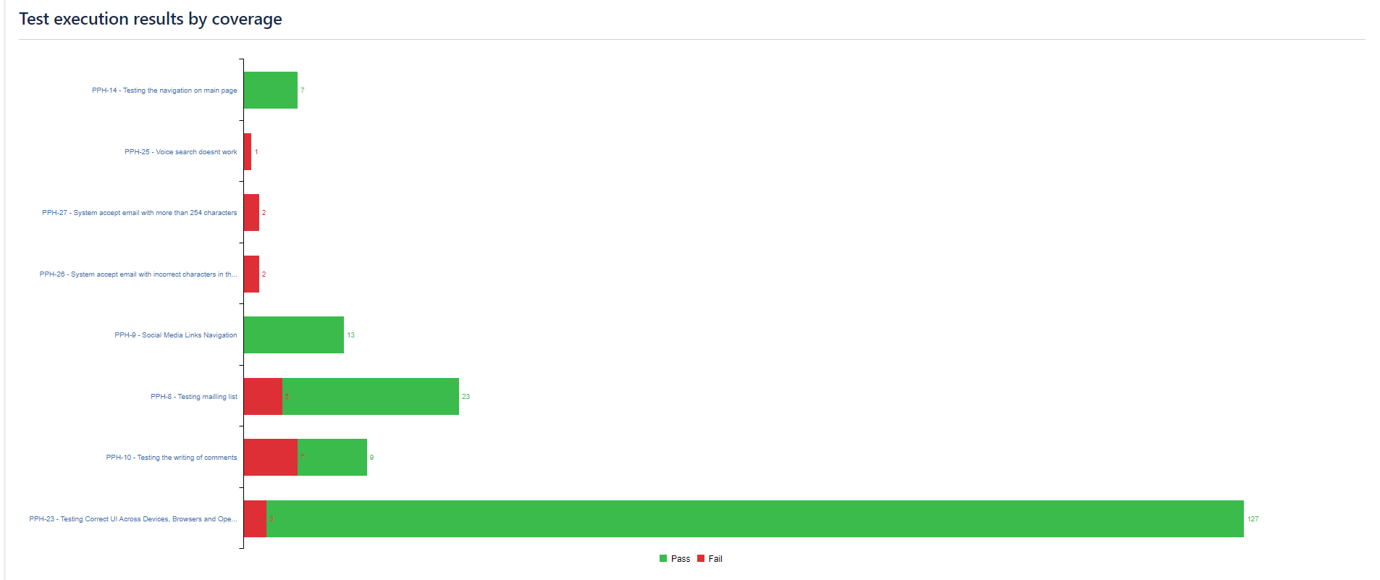

### **5. Team performance analysis**

During the testing of our team, we demonstrated high efficiency due to clear communication, division of responsibilities, and cooperation. Each team member was responsible for their specific tasks, which allowed us to quickly resolve issues and achieve our goals. Regular communication and discussions allowed for timely information exchange and feedback, which had a positive impact on productivity.

Cooperation and a friendly atmosphere were an important part of our success. We used various communication platforms, such as Telegram and Zoom, to discuss problems and get quick solutions. In the event of difficulties, such as a power outage, we supported each other, shared resources and information through mobile devices. Sometimes we redistributed tasks among ourselves if one of us was unavailable or busy. This helped us to work with a different field of activity and see more opportunities for testing with fresh eyes. Active cooperation and the absence of specific deadlines allowed the team to continue testing and quickly resolve critical issues that arose without conflict or any problems.

Throughout the entire testing process, we developed the plan together, collectively, which contributed to the active involvement of all participants. Each of us made suggestions, ideas and comments, which we discussed and improved in detail. This allowed us to create a structured approach to testing, where everyone had the opportunity to express their opinions. During the execution of the test scenarios, we distributed responsibilities, determining who was responsible for which part: Maryna was responsible for testing the functionality of distributing articles to other sites, Tanya wrote test cases for the search field, and Anton focused on commenting on articles. After we finished writing the tests, we mutually checked each other by testing the cases written by our colleagues. This approach to rotating responsibilities helped improve the quality of testing, as each participant had the opportunity to look at the functionality from a different perspective and identify potential flaws that had not been noticed before. This contributed to a better understanding of all aspects of the project and improved teamwork.

Collaboration during testing was especially important in the context of unstable access to electricity and the Internet. When difficulties arose, such as power outages, team members quickly adapted by organizing testing sessions on the devices that were available at the time.

The distribution of roles in the team proved to be effective. Each member knew his or her responsibilities and was free to discuss and offer ideas. The project manager (Maryna Filipiieva) provided overall oversight, ensuring that the jointly developed requirements and progress were met. This approach helped avoid conflicts and increased team synergy. For example, during feature testing, which required intensive collaboration, the teams successfully worked together, sharing data and results.

### **6. Problems and challenges**

During our testing, we faced a number of challenges. To begin with, the site owner granted us access only as users, without the ability to test registration or authentication, as these features were not available on the site. This limited our ability to gain experience in these aspects of testing, which could have been useful for future work.

We also did not take into account the importance of using checklists. Initially, we wrote UI and Usability tests as regular test cases, which turned out to be inefficient. Using checklists would have simplified the process significantly, but due to our lack of experience, we missed this opportunity.

Testing in different environments, in our opinion, took too much time. We're not sure if this is normal for real-world projects, but we felt like this process could be optimized.

Automation in the Selenium IDE proved to be challenging due to our limited experience. We lacked the knowledge of basic programming to write the right targets and commands. This led to slow progress and difficulties in executing tests.

Since there were only three of us and no developer at all, we were unable to perform regression testing after discovering bugs, which was also a significant limitation.

Finally, documenting the test cases was another challenge. When saving the test cases from Zephyr Scale to Google Sheets, the formatting was broken - cells were shifted, texts overlapped, making the document difficult to read. We had to spend a lot of time fixing it and making the document readable.

The biggest challenge we faced was not having enough experience in testing, and not having enough support from an experienced mentor. Consultations with a specialist could have streamlined our work, provided a clearer testing structure, and helped us solve many of the difficulties we faced. Feedback from an experienced mentor could have been an important resource for improving our productivity and increasing the quality of our testing.

### **7. Results**

### As a result of our testing, we have significantly expanded our knowledge and skills in using the Jira, Zephyr Scale, and Selenium IDE platforms. This project gave us the opportunity to learn how to test key features, understand the basics of UI and Usability testing, and adapt to extreme conditions, which greatly increased our confidence.

### We have succeeded in implementing key features as well as in testing the UI design, which has had a positive impact on the overall user experience. Among the important achievements is our ability to use GitHub to upload the project, which allowed us to demonstrate our work to colleagues and potential employers.

### This project was not only a learning platform for us, but also a real challenge that gave us invaluable experience. Collaboration with team members, expanding our knowledge and skill horizons opened up new perspectives for our professional growth. We look forward with pride, as this experience has become a solid foundation on which we will build our careers in the testing industry.

### 

### **8. Applications**

The Applications to this report, as well as other materials, are available in signed folders on GitHub and can be found in the public domain.